**Assessment 1 – Case Study**

**Project management**

**70351 Tomohiro Matsuyama**

**My website:** <https://tomm66.github.io/70351project-managment/>



Contents

Instruction: 2

Duration: 2

Case Study: 2

Going Green application, Green IT Project Management 2

Project profile 2

Business situation 4

Your tasks: 4

Task 1: Identify Business Strategy and Gap 4

Task 2: Recommend a feasible solution 5

Task 3: Produce a Project Charter 5

Task 4: Project Document 6

Task 5: Project Closure 9

Helpful web links to complete the assessment: 12

Search Index 13

## Instruction:

This task is to be completed individually. You need to analyse a case scenario and complete all the tasks mentioned after the scenario.

You need to demonstrate your IT project management ability to identify business strategy and gaps. You will also need to suggest a feasible solution to overcome identified gaps and produce a project charter along with a WBS to implement the proposed solution.

### Duration:

Trainer will set the duration of the assessment.

All my working could be checked at: <https://tomm66.github.io/70351project-managment/>

Refer <https://wellsjohn220.github.io/pm12345t42022>

## Case Study:

### Going Green application, Green IT Project Management

# Project profile

Going “Green” is a mission of many companies around the globe not just for reasons of environmental responsibility, but also for cutting costs in these extremely tight economic times. Green IT efforts represent a specific focus area within enterprises that hold attention to this trend. Green IT leverages information technology to streamline operations, cut costly waste, and reduce the impact on the environment. IT typically consumes only about 10% of an organization’s energy costs, but the net effect of a Green IT project is to go beyond just energy saving. To tackle the other 90%, a Green IT project extends into a variety of other departments, and to execute such an endeavour requires an effective project management function in order to identify and prioritize goals. A Green IT transformation can be a complex process.

Vital Statistics:

* Number of project tasks - 12
* Project duration - 16 months
* Project budget - $1,200,000
* Number of users - 50

## Your tasks:

### Task 1: Identify Business Strategy and Gap

Document the business’s strategies of “Green IT” and also summarise the components required changes for the participating organisation to implement “Green IT Project”. (Min. 300 words)

The development of a business strategy is a planning function of any organisation and incorporates having a strategic plan. This “Green” project is crucial for cost reductions and environmental advantages. At the present, the use of computers and networks affects many aspects of life. Therefore, the strategies of the Green IT project would have a great potential to influence on the environment and energy efficiency.

As a means of achieving the goal of going "Green," it is used by organisations to save money and accomplish more with less work, provide them with a way to overcome the difficulties of understaffing and limited resources, and increase intangible benefits like differentiation from competitors and company morale. Energy efficiency has become a crucial business goal since energy demand is rising faster than energy production.

The action plans for a Green IT project included the four main objectives as below:

* To revise processes and metrics
* To optimise efficiency of existing IT assets
* To revamp architecture and infrastructure
* To position IT to enable green business practices.

In order to evaluate the action plans, the gap analysis is used and and followed by the analysis process. The strategic plan of the organisation sets out the goals a business hopes to achieve within a specified period of time. It also helps the organisation understand the environment within which they operate and the market forces that affect them. An analysis of the current strategic plan enables you to understand the goals of your organisation. In the gap analysis, the rating system is used to find our priority matters and difficulties.

Chart 1, The gap identification and the process of gap analysis

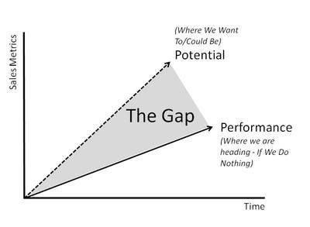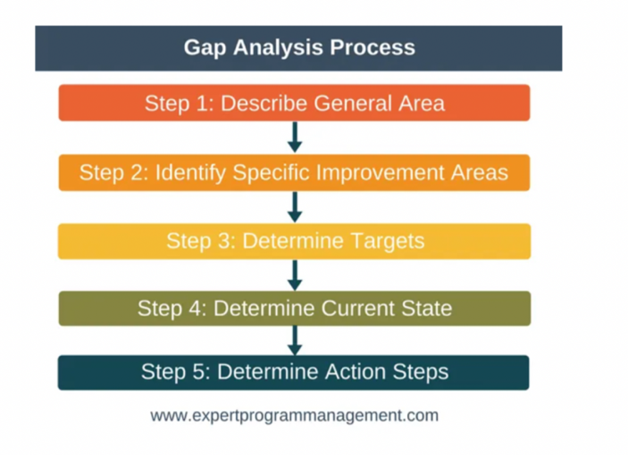

**Analyse Strategy**

The strategic plan of an organisation sets out the goals a business hopes to achieve within a specified period of time. It also helps the organisation understand the environment within which they operate and the market forces that affect them. An analysis of the current strategic plan enables you to understand the goals of your organisation. However, in order to analyse the strategic plan, you first need to understand the structure and purpose of a strategic plan. This topic describes the elements that make up a strategic plan. The green project we need defined every requirement. The gap which is between your plan and reality always need your notice.

**Gap rating analysis**

# Gap analysis is defined as a method of assessing the differences between the actual performance and expected performance in an organization or a business. Rating can be used to help you find out which tasks should be prioritised and those which need reviewing and amending. The strategic plans are scored at the rate of 1 to 9, with 9 being the result of the largest gap between performance and potential. The higher the gap, the more work needs to be done and the longer it will take. For some companies, those with no gap difference are considered feasible in terms of time and budget as well as environmental contribution.

1.Server Virtualization 2. Server Power Capping 3. Active Power Management 4. Alternative Energy Plan 5. Computer Hardware Recycling 6. Paperless Accounting 7. Data Centre Chargeback Model 8. Data centre Cooling and Airflow 9. Energy Efficient Coding Practices 10. Measure Data centre Energy Use 11. Printer and Display Efficiency 12. Telecommuting Programs are evaluated below;

|  |  |  |  |  |  |  |  |  |  |  |  |  |  |  |  |  |  |
| --- | --- | --- | --- | --- | --- | --- | --- | --- | --- | --- | --- | --- | --- | --- | --- | --- | --- |
| **GAP ANALYSIS 1-6** | | | | | | | | | | | | | | | | | |
| **Strategic Plans** | | **Gap Rating** | | | | | | | | | | | | | | | |
| **Minor** | | | | | | **Moderate** | | | | | **Major** | | | | |
| **1** | | **2** | | **3** | | **4** | | **5** | | **6** | **7** | **8** | | **9** | |
| 1 | **Server Virtualization**  Reduce the number of physical servers by running several virtual machines on a single physical server using virtualization technology | **√** | |  | |  | |  | |  | |  |  |  | |  | |
| **Description** | | | | | | | | | | | | | | | |
| * It can have a high cost of implementation. Hardware and software are required at some point and that means devices must either be developed, manufactured, or purchased for implementation. * Not every application or server is going to work within an environment of virtualization. * **Requires several links in a chain that must work together cohesively** | | | | | | | | | | | | | | | |
| 2 | **Server Power Capping**  Capping the power drawn by servers. The power capping eliminates the need for over provisioning, allowing the company to reclaim trapped energy. The power allocations will be set in advance, based on previous server history. |  | |  | |  | |  | | **√** | |  |  |  | |  | |
| **Description** | | | | | | | | | | | | | | | |
| * Need to investigate how much the company uses the power for the server when running at maximum utilization * The idea of using a power capping system has been started over the course of last 20 years. Most of companies would have applied with this strategy. * The only articles on server power capping that come up in the top Google search result are old ones. This means this is not innovative idea | | | | | | | | | | | | | | | |
| **3** | **Active Power Management**  The goal is to cut the amount of time PCs are powered on by more than half, from 21 hours to 10.3 hours daily, estimating it will save about $750,000 on energy annually by deploying active power management solutions. Studies show that PCs stay on more than double the amount of time they need to. This translates to an amount of wasted energy that costs about $150 per system per year. |  | **√** | | | |  |  |  | |  | |  |  | |  | |
| **Description** | | | | | | | | | | | | | | | |
| * Since corona pandemic, our working style has changed to be more accepting of remote and hybrid work. * The PCs at the company is not used fully. The guidelines have been made to reduce the time that the PCs are used in order to save energy. | | | | | | | | | | | | | | | |
| 4 | **Alternative Energy Plan**  Alternative energy sources are an important characteristic of a green data centre so the company will investigate relocating the data centre where wind or hydro power is widely available. The company will also explore the use of solar energy rather than diesel for backup. |  |  | | | |  |  |  | |  | | **√** |  | |  | |
| **Description** | | | | | | | | | | | | | | | |
| * Many companies consider relocating the data centre close to wind or hydropower plant. These areas are getting occupied and this is not feasible plan to do. * Some companies started to invest money into wind turbines to get sustainable energy, however it can be over their budget. | | | | | | | | | | | | | | | |
| 5 | **Computer Hardware Recycling**  The company plans to follow the trend that 40% of companies already have in place, computer hardware recycling. Company issued cell phones will be part of this initiative. | **√** |  | |  | | |  |  | |  | |  | |  | |  |
| **Description** | | | | | | | | | | | | | | | |
| * This refers “Life cycle management” to reduce hazardous waste. There is an issue with landfills to sort out waste all over the world. Hardware recycling is a method that can be used to deal with this issue. | | | | | | | | | | | | | | | |
| 6 | **Paperless Accounting**  The company shall develop IT solutions to encourage customers to take advantage of paperless bi l ling and payments. |  | **√** | | | |  |  |  | |  | |  | |  |  | |
| **Description** | | | | | | | | | | | | | | | |
| * With the development of technology, we started to use digital documents to reduce the amount of printing over the course of last ten years. * We have been successful in reducing this already and all our clients are happy to take digital documents instead of papers | | | | | | | | | | | | | | | |

|  |  |  |  |  |  |  |  |  |  |  |  |  |  |  |  |  |  |
| --- | --- | --- | --- | --- | --- | --- | --- | --- | --- | --- | --- | --- | --- | --- | --- | --- | --- |
| **GAP ANALYSIS 7-12** | | | | | | | | | | | | | | | | | |
| **Strategic Plans** | | **Gap Rating** | | | | | | | | | | | | | | | |
| **Minor** | | | | | | **Moderate** | | | | | **Major** | | | | |
| **1** | | **2** | | **3** | | **4** | | **5** | | **6** | **7** | **8** | | **9** | |
| 7 | **Data Centre Chargeback Model**  The Company plans to determine data centre usage on a per department basis so more use is charged back more heavily to the department with the most use. |  | |  | |  | |  | |  | | **√** |  |  | |  | |
| **Description** | | | | | | | | | | | | | | | |
| * Chargeback tends to reduce overall resource consumption as business units stop hoarding surplus servers or other resources to avoid the cost of maintaining underutilised assets. At the same time, organizations experience increased internal customer satisfaction with IT as it becomes more closely aligned with the business units and they begin working together to analyse and improve efficiency. * A chargeback model makes consumers accountable for the environmental impacts of their service usage. | | | | | | | | | | | | | | | |
| 8 | **Data centre Cooling and Airflow**  The Company plans to reduce data centre operational costs and carbon footprints by reducing the amount of power needed to run and cool the facilities. To do this, the company will recycle more than 302,000 gallons of water a day at the data centre and will also  collect rainwater off its roof and store it underground in a 50,000-gallon tank for cooling IT systems. |  | |  | |  | |  | |  | |  | **√** |  | |  | |
| **Description** | | | | | | | | | | | | | | | |
| * The number of data centres is expected to increase in the next twenty years. As a result, we need to save water and energy. * We would like to recycle 100 % of waste water, however, due to the technical issues, it seems impossible to make it happen with the current data centre recycling system.   . | | | | | | | | | | | | | | | |
| **9** | **Energy Efficient Coding Practices**  Thought should be given to understanding how much power custom developed software applications will use even as they are being coded. The company’s IT department shall advise developers to determine which query method for example, might save a watt of energy and choose that method even if it might make the process slower by a nanosecond or two. |  |  | | | |  |  |  | |  | | **√** |  | |  | |
| **Description** | | | | | | | | | | | | | | | |
| * We tried to carry on this project, however, some developers have h moved back to their countries. Due to the pandemic, web developers appear to not be staying at the company for a long time. This means that it is hard to advice for them to change their coding with the aim of using environmentally friendly code. * Also, some languages such as HTML, CSS, JavaScript etc have been updating new style effectively and efficiently to contribute environmental protection. * Considering the company size and human resource situation, this is not ideal to carry on. | | | | | | | | | | | | | | | |
| 10 | **Measure Data centre Energy Use**  The Company’s data centre must be more energy efficient by deploying sensors measuring nearly all power consumption. The company will measure total data centre energy use every 15 minutes and monitor at the subsystem level. This will develop baseline metrics and find trouble spots, taking measurements over the course of a year. The stated goal is to increase CPU utilization by 10% and cut power use by 5%. The long-term goal is to obtain EPA Energy  Star rating for the data centre. The Power Usage Effectiveness (PUE) score compares the overall  amount of energy used in the datacentre for all functions including computing, cooling, and power distribution, to the amount that just goes into computing. A lower PUE is better and a value of 1 is the goal. | **√** |  | | | |  |  |  | |  | |  |  | |  | |
| **Description** | | | | | | | | | | | | | | | |
| * Combining current monitoring sensors with energy monitoring software to monitor each machine’s energy use can help to give organisations accurate, real-time energy consumption data and show usage over time. | | | | | | | | | | | | | | | |
| 11 | **Printer and Display Efficiency**  The Company plans to encourage employees to print on both sides of paper and cut duplicate printing. The company shall also initiate a campaign to have employees turn  off their screens if they are going to be away | **√** |  | |  | | |  |  | |  | |  | |  | |  |
| **Description** | | | | | | | | | | | | | | | |
| * With the development of technology, we started to use digital documents to reduce a number of prints over the course of last ten years. * We have been successful in reducing already and all our clients are happy to take digital documents instead of papers | | | | | | | | | | | | | | | |
| 12 | **Telecommuting Programs**  The company shall institute guidelines to replace eco unfriendly air travel with tools for virtual work, such as instant messaging (IM) and teleconferencing. In addition, general telecommuting programs shall be instituted. IT’s role is significant when putting a telecommuting policy in place. |  |  | | | |  |  |  | |  | | **√** | |  |  | |
| **Description** | | | | | | | | | | | | | | | |
| * Email, SMS or instant message has an environmental impact. Due to the convenience of quick replies , we cannot avoid to use them. * The world’s text messaging exchange is estimated to emit 32,000 tons CO2e per year. This carbon footprint is very small when compared to humankind’s total carbon footprint: 40 billion tons CO2e per year | | | | | | | | | | | | | | | |

Task 2: Recommend a feasible solution

Assume “Wells International College” is thinking of going “Green” and asked for your assistance in this project. Research different project management applications on the Internet to compare with the Green IT project management application and recommend a feasible solution with proper reasons for Windsor. (Min. 300 words)

When comparing the options, option 1 and option 2 are taken from “IT Green project” above and option 3 is taken from a real sustainable strategy of Australian university as it is useful to pick up some strategies from same filed as “Wells international college”. In the feasibility analysis, four main components such as operational, technical, economical and schedule feasibility are used to find the best option for Wells international college. Based on the feasibility analysis below, the option 2 (printer and display efficiency) has a compelling result to support the use of this strategy. The only requirement of this option is that employees are instructed on how to print both sides of paper. This means that nor need complicated skills are required by the employees and there is no need to purchase new printers. However, if the environmental factors are prioritised , paperless accounting would outweigh the option (printer and display efficiency).

1. **Paperless Accounting (See task 1)**
2. **Printer and Display Efficiency (See task 1)**
3. **Use Environmentally friendly products**

Purchase environmentally friendly products for use on campus, such as 100% recycled paper. Universities have leverage to create new markets here. Nowadays, all the information we need can be found online and we can do all of our work on our laptops too. This makes it easier to access and share information with each other. In this case, there is a clear benefit to not using paper for taking notes or solving questions when we have ways to keep these notes safe online instead. Although in some cases, physical prints are required for those who likes to see paper documents.

**Feasibility analysis**

|  |  |  |  |
| --- | --- | --- | --- |
|  | **Paperless Accounting** | **Printer and Display Efficiency** | **Use Environmentally friendly products** |
| **Operational feasibility** | **○** | **◎** | **○** |
| **Technical feasibility** | **○** | **○** | **◎** |
| **Economic feasibility** | **◎** | **◎** | **○** |
| **Schedule feasibility** | **△** | **◎** | **○** |

### Task 3: Produce a Project Charter

Please view my project charter

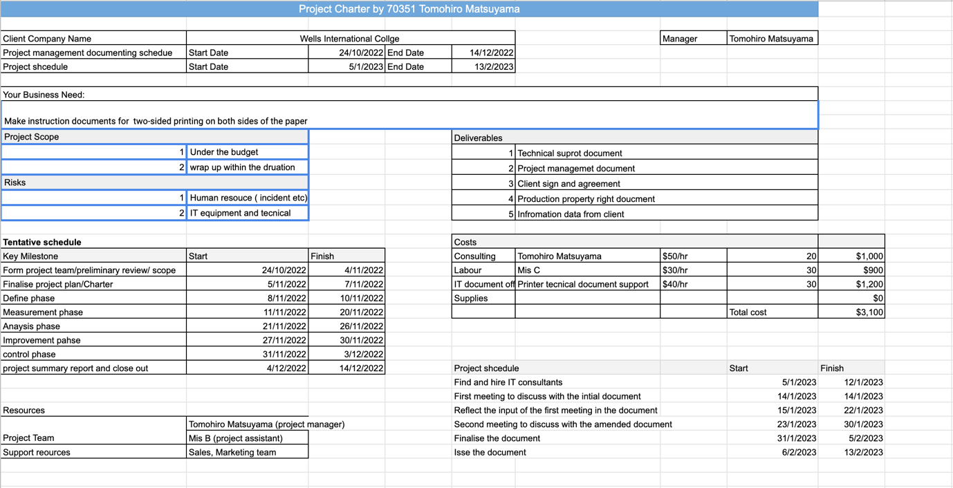

### Task 4: Project Document

Please check my site: <https://tomm66.github.io/70351project-managment/>

Updated 1. My GANT CHAR SOLUTION

2. Example Demo

2.1 index

2.2 Gantt

2.3 Task

2.4 Resources

2.5 About

3. Download Assessment 1 and 2

4. Our values

5. Show Project Gant chart and resource

6. Services

7. Project Team

8. Project need to define

9. We love our project management course

10. Loading

11. QR code

1. Introduction

Sustainable colleges make sustainability a major priority in its teaching and research. At Wells International College, the curriculum covers sustainability and communicates with the students in an attempt to help Sustainable Development Goals (SDGs). Wells can contribute sustainable process in a number of ways through educating students about the importance of sustainability in any field of studies, conducting research on sustainable challenges and reducing the footprint of its campus. Wells has initiated a few green projects such as using paperless documents and printing on both sides of the paper. Studying at Wells college can be beneficial for students to understand environmental contributions in any fields. Showing the college’s environmental contribution is essential to attracting other colleges and it can encourage more students and stockholder to get involved environmentally friendly actions. “Green IT project (task2) “is developed in Task 4 to enhance the study. Sustainable video production project to introduce sustainable actions in Wells college is evaluated as below the sections.

1.2 Scope and objective of the project

|  |  |
| --- | --- |
|  |  |
| **Objectives** | 1.Promote the sustainable campaign in Wells international college  2.Raise the awareness of Environmental problems  3.Show our commitment to the goal of sustainability |
| **Project Scope** | * Plan scope management * Gather information * Define scope * Make working breakdown structure * Verify scope * Control Scope |
| **Scope** | * To make sustainable video production under the budget * To hire unknown video editor under the budget |
| **Constrains** | * Budget has been limited by WIC Capital Expenditure of current fiscal year for Hardware $80,000, Software $10,000, and Outsourcing man-hours $100,000 |
| **Project Deliverable** | * Paperwork included signed and executed licensing agreement for the video, and omission report (internal deliverable) * Initial report strategy report * Budget report * Progress report * Test and Evaluation report * Focus group summary report * Survey data * Sustainable promotion video (external deliverable) |

1. Information gathering process and approach

Background study

-- Case Study Review—

Refer Task 1

Focus group meeting

ES survey

Design

----Feasibility and cost analysis---

---Communication plan---

---Risk management ----

Requirements testing

Evaluation

Final requirements identification

------Recommendations -------

----Documentation--------

1. Focus group and Survey

3.3 Focus Group

Making a group to answer questions in a moderated setting. Focus groups are a type of  qualitative research. Observations of the group’s dynamic, their answers to focus group questions, and even their body language can guide future research on consumer decisions, products and services, or controversial topics. Asking for feedback about initial project plans plays a key role in improving projects.

3.2 Survey based on ES aspects

Use both open question and closed questions;

1.To permit an unlimited range of answers

2.To reveals how the respondents think about the question

3.To expand on and clarify closed responses

Environmental Social Governance (ES) Survey

|  |  |  |
| --- | --- | --- |
|  | **Environmental** | **Social** |
| 1 | Please list, if any, the firm’s climate related opportunities. What kind of environmentally friendly aspects do you want to put in this project? | Does your company conduct any other community engagement activities aside from those directly connected to the business? |
| 2 | Please list the firm’s three primary risks related to climate change | Circular economy: How are purchases and waste managed? Please list the firm’s demands on its suppliers, if applicable |
| 3 | Can you score this plan? and are there any further improvements you can suggest? | Are there any goals for sustainability for your company? What social aspects can you contribute in sustainable goal? |

**Gannt chart and resource sheet**

Because I could not get Ms-Project software. I use google Sheets to made Gantt chart template:

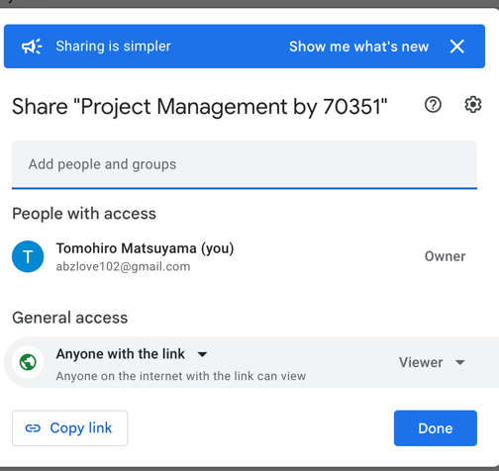<https://docs.google.com/spreadsheets/d/1im6mKa1ZCI1aVueTZT7NWa4bmFpfRVA1jK_8gWapU_g/edit#gid=0>

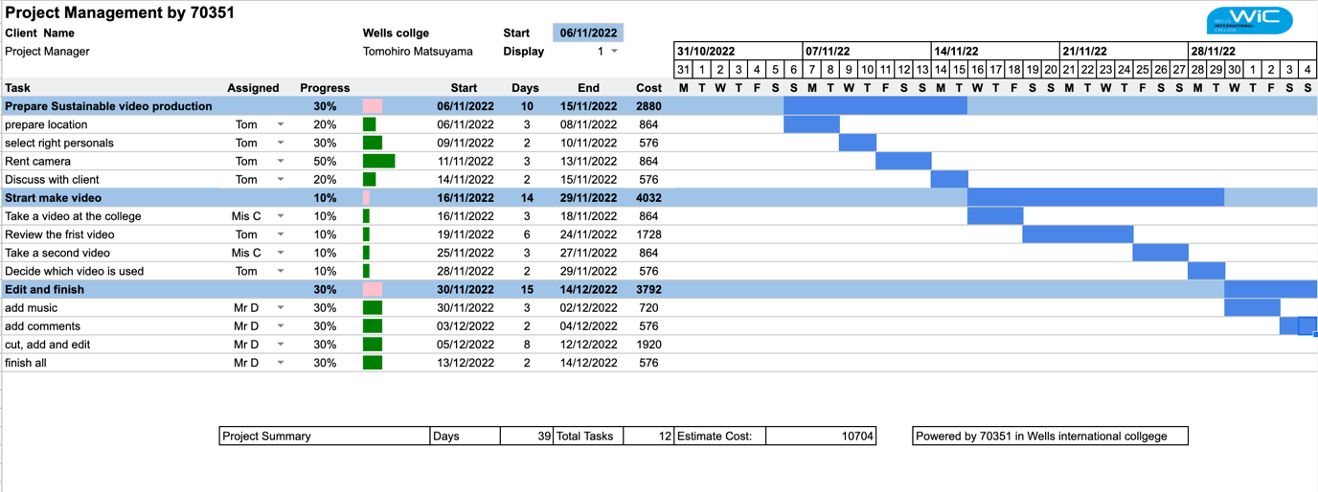

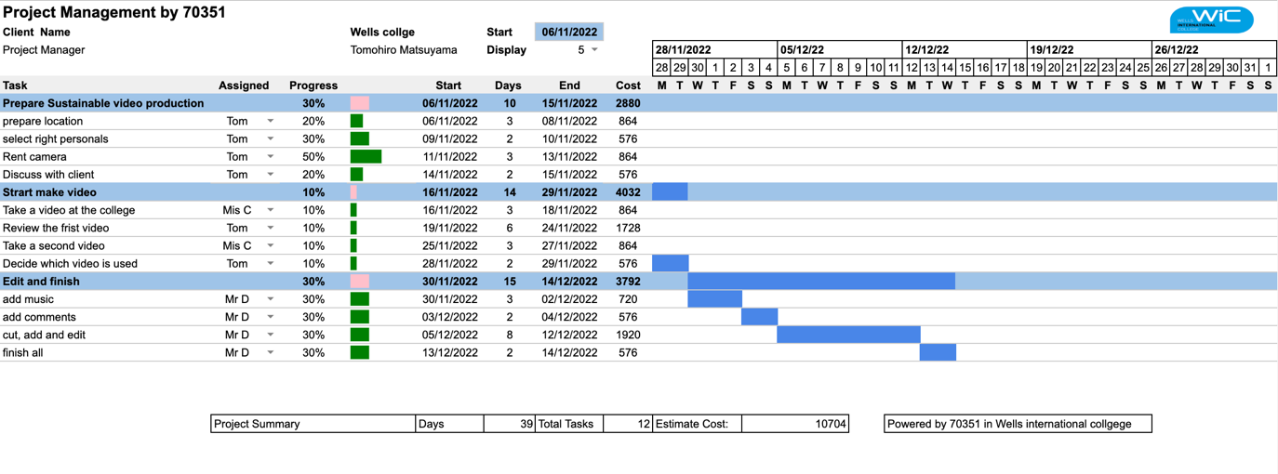

Estimate human-outsource cost within WIC budget (Outsourcing man-hours $100,000)

Total estimate cost

|  |  |
| --- | --- |
| Personals cost | $10704 |
| Equipment cost (camera hire 12 days) | $960 |
| Total | $11664 |

Resource sheet

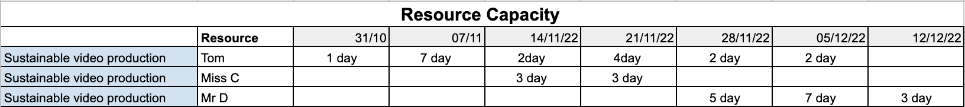

Communication plan

|  |  |  |  |
| --- | --- | --- | --- |
|  | Contact | Notes | Impact on the project  (1 = Low, 2 = Medium, 3 = High, 4 = Critical) |
| Video Editor  Mr D | [blackcatvideo@gmail.com](mailto:blackcatvideo@gmail.com)  ph:34488812 | Prefer: Email | 4 |
| Director of Wells international college | [david1212@wells.com](mailto:david1212@wells.com)  ph:12344888 | Prefer: Phone | 3 |
| Director of department of marketing at Wells international college | [Kate7812@wells.com](mailto:Kate7812@wells.com)  ph:99344888 | Prefer: Email | 4 |
| Director of department of accounting at Wells international college | [madaline12@wells.com](mailto:madaline12@wells.com)  ph:56744888 | Prefer: Email | 4 |
| Director of legal department at Wells international college | [tom1d1c@wells.com](mailto:tom1d1c@wells.com)  ph:12344888 | Prefer: Phone | 3 |
| Director of information system a Wells international college | [hamish1oo2@wells.com](mailto:hamish1oo2@wells.com)  ph:99904888 | Prefer: Email | 3 |
| Project manager  Tomohiro Matsuyama | [tom@gmail.com](mailto:tom@gmail.com)  ph:000344888 | Prefer: Phone | 4 |
| Project member 1  Mis C | [1234@gmail.com](mailto:1234@gmail.com)  ph:34488844 | Prefer: Phone | 3 |
| Director of Project Management Support | [2345@gmail.com](mailto:2345@gmail.com)  ph:000344888 | Prefer: Email | 3 |

Change and control management

|  |  |  |  |  |
| --- | --- | --- | --- | --- |
| **Deliverable info** | **Recipients** | **Delivery Methods** | **Schedule** | **Who’s responsible** |
| Project information | Project Team | Share points  Team meetings  Conference calls | As needed | Project manger |
| Project status | Project planer  Director | Email  Google docs | Every Tuesday | Project manger |
| Agenda/ Minutes | Project Team | Email  Share points  Team meeting | Every 4 weeks | Project manger |
| Timeline Update | Project manger  Sponsor etc | Meetings  Google docs  Share points | As needed | Project manger |
| Project Updates  Action Item status | Project Manger | Team meeting  Email  Conference calls | As needed | Project Team |
| Project Risks | Project team  Project steering committee  Sponsor etc | Risk document  Meeting Minutes | As needed | Project manger |

Identified Risk and Contingency

|  |  |  |  |  |
| --- | --- | --- | --- | --- |
|  | How long can you do without? | Impact of Doing without? | Vulnerabilities? | Contingency in case of a disaster or trouble? |
| Equipment (IT) | 5 days | Delay some communications  and update reports | Old software, poor security | Update software and security  Use backup data |
| Facility | 0 day | No production available  No access to IT | Old building, flood zone, poor maintenance | Use temporary office |
| Personal | 0 day | Degraded operations, slow down the project | Unexpected sick or disease | Best effort is to shifting of available staff |

Conflict management

|  |  |
| --- | --- |
|  | Description |
| Commination | Listen without interrupting each other. Present your [point of view of the situation. Explain how you feel. |
| Compromise | Moderate concern for others and moderate concern for the ultimate goal are exhibited, and a focus is placed on achieving a reasonable middle ground where all the parties can be happy |
| Avoiding | Avoid any argument with someone, not wanting to start any fights. |

### Task 5: Project Closure

Prepare project closure document template as following:

* Project Sign-off document

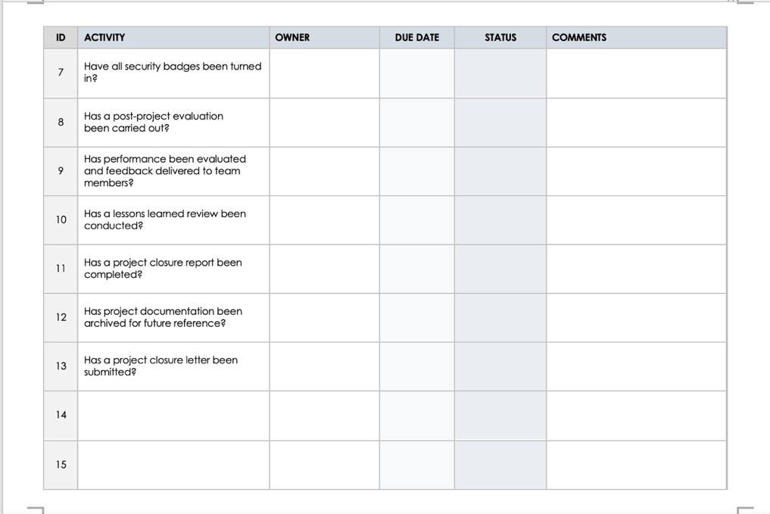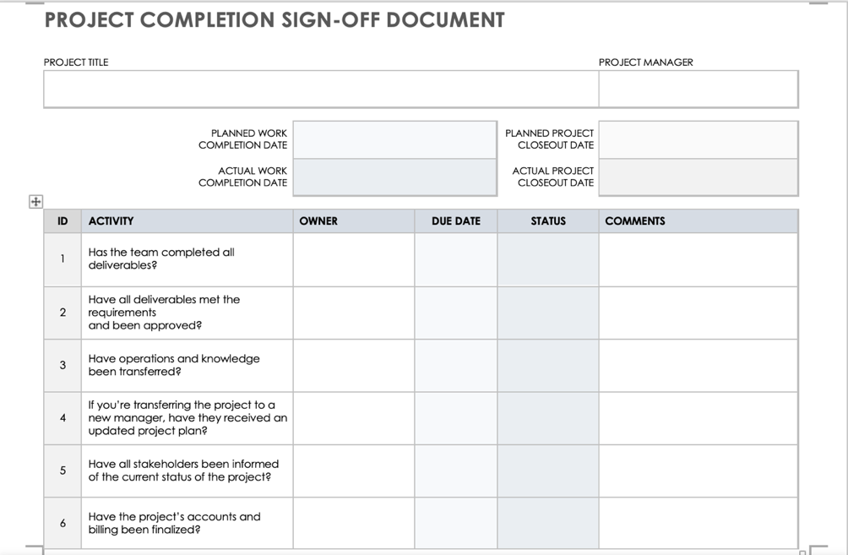

**­­**

|  |
| --- |
|  |

**Project evaluation**

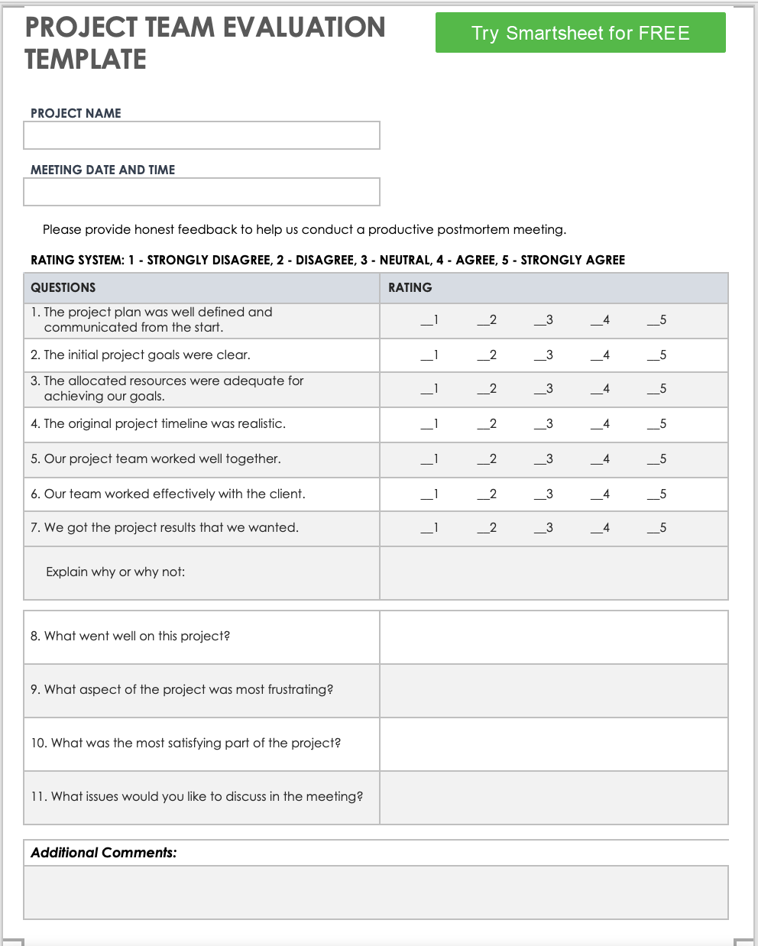

# LESSONS LEARNED DOCUMENT

|  |  |  |
| --- | --- | --- |
| **Project Name/Number:** | **Prepared by:** | **Date:** |
|  |  |  |
| **Customer/End User Group:** | **Contact Name:** | **Project Type (S/M/L):** |
|  |  |  |
| **Business Unit:** | **Project Manager:** | **Project Sponsor:** |
|  |  |  |

Summary of Lessons Learned

|  |
| --- |
| **Project Background** |
|  |
| **Summary of Lessons Learned** |
|  |
| **Overall Recommendations** |
|  |

Technical Performance

|  |
| --- |
| **Project Experience** |
|  |
| **Recommended Process Improvements** |
|  |
| **Other Recommendations** |
|  |

SCHEDULE PERFORMANCE

|  |
| --- |
| **Project Experience** |
|  |
| **Recommended Process Improvements** |
|  |
| **Other Recommendations** |
|  |

cost Performance

|  |
| --- |
| **Project Experience** |
|  |
| **Recommended Process Improvements** |
|  |
| **Other Recommendations** |
|  |

risk management

|  |
| --- |
| **Project Experience** |
|  |
| **Recommended Process Improvements** |
|  |
| Other Recommendations |
|  |

Team management

|  |
| --- |
| **Project Experience** |
|  |
| **Recommended Process Improvements** |
|  |
| **Other Recommendations** |
|  |

tools performance

|  |
| --- |
| **Project Experience** |
|  |
| **Recommended Process Improvements** |
|  |
| **Other Recommendations** |
|  |

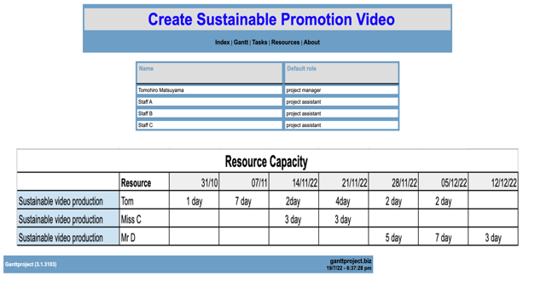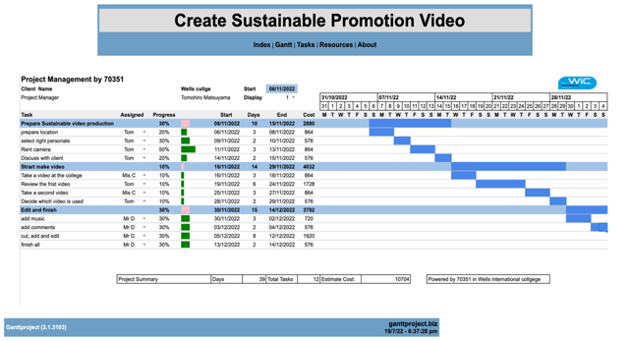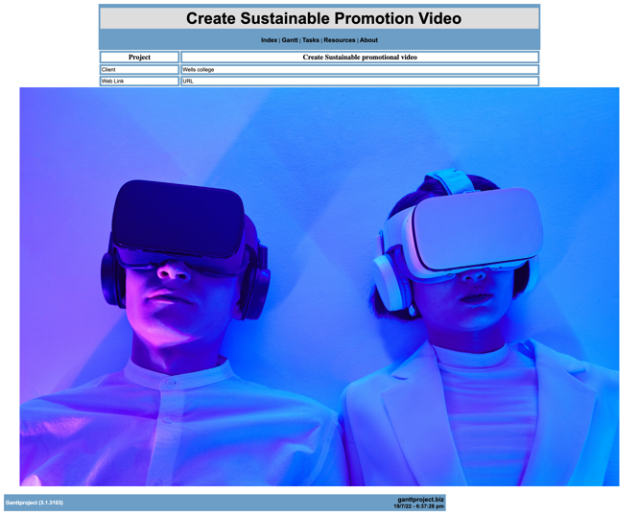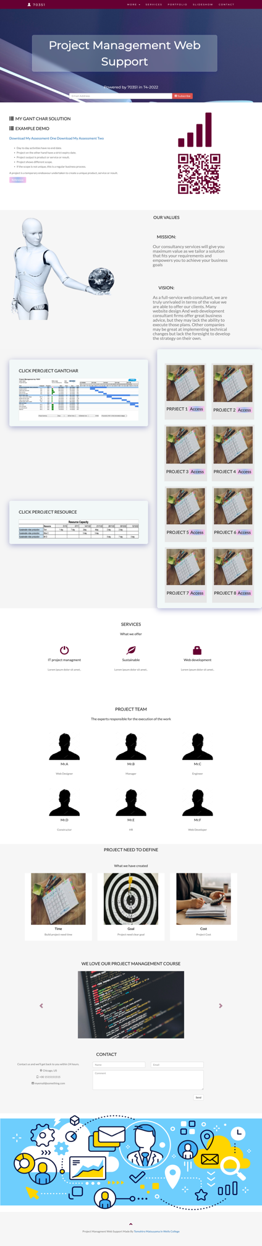Ap­­­­­­­­pendixes

­­­­

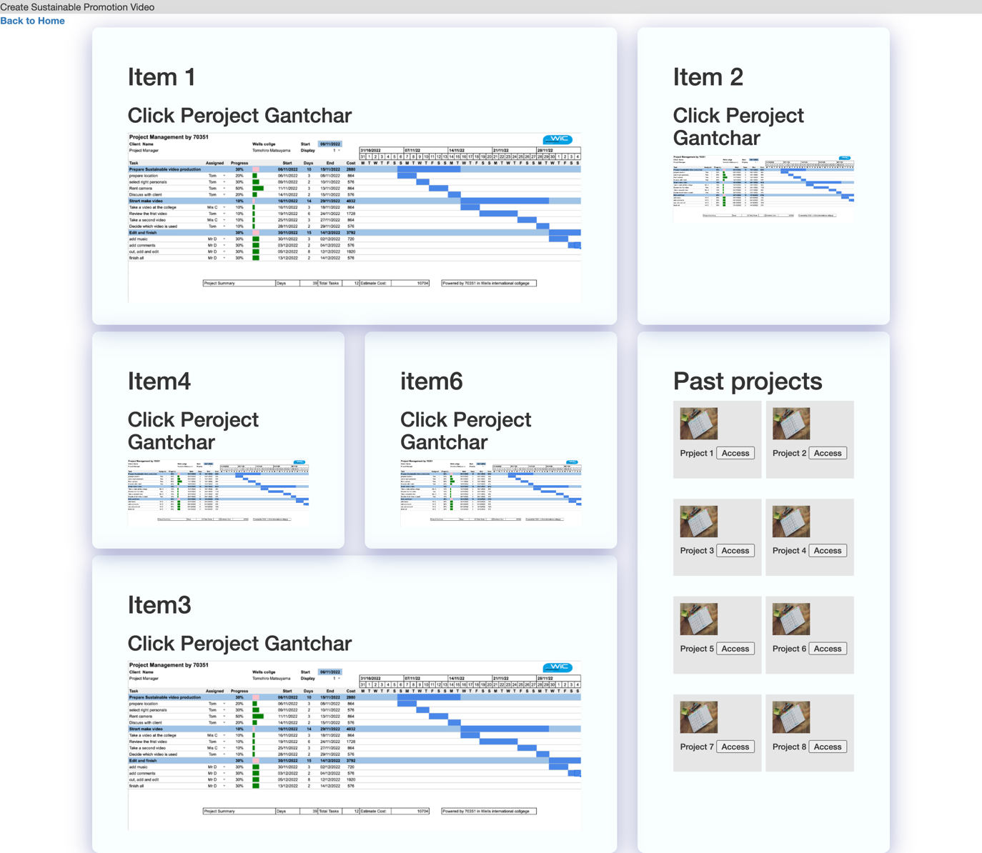

This will make your project management easier!